**Amazon S3 Transfer Accelerator:** Increase transfer speed by transferring file into an AWS edge location which will forward the data to the S3 bucket in the target region. [S3 bucket is specific to a particular region]

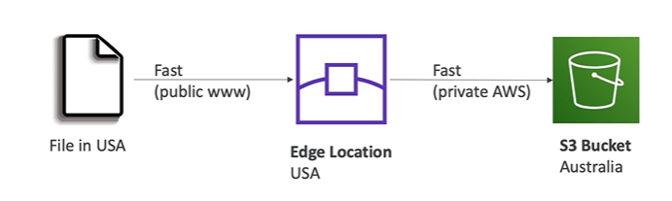

**AWS Global Accelerator:** It is used to improve the global application availability and performance using the AWS global network. It uses AWS internal network to optimize the route of your application by almost 60%

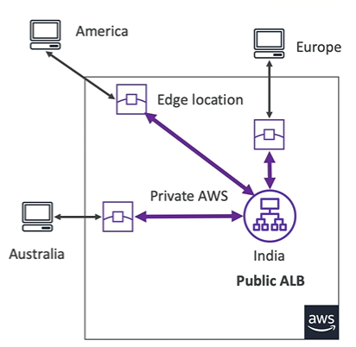Application is hosted in India.

The benefit we get out of it is that the traffic on the public internet only happens between America and the closest edge location and then it leverages the private AWS network to speed up the connection from the edge location.

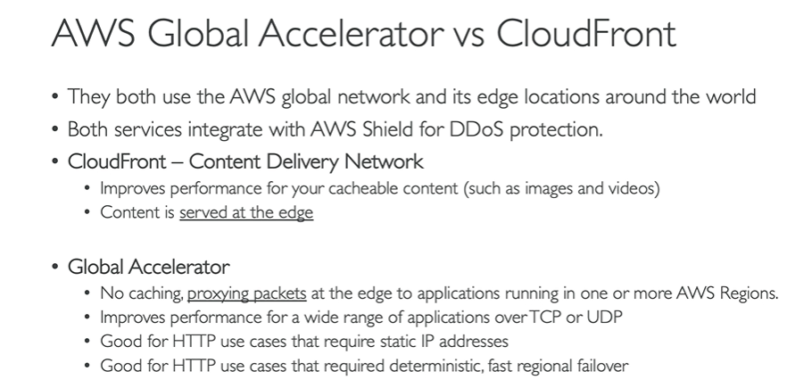

**AWS Outposts:** AWS Outposts are “server racks” that offer the same AWS infrastructure, services, API, and tools to build your own application on-prem just as in the cloud. AWS will setup and manage “**Outpost Racks**” [servers] within your on-prem infrastructure and you can start leveraging AWS services on-prem. This is generally used for companies that want to use hybrid cloud.

For the EC2 instance running in AWS Outpost, you’re responsible for physical security of the EC2 instance

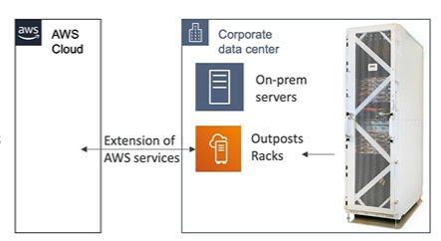

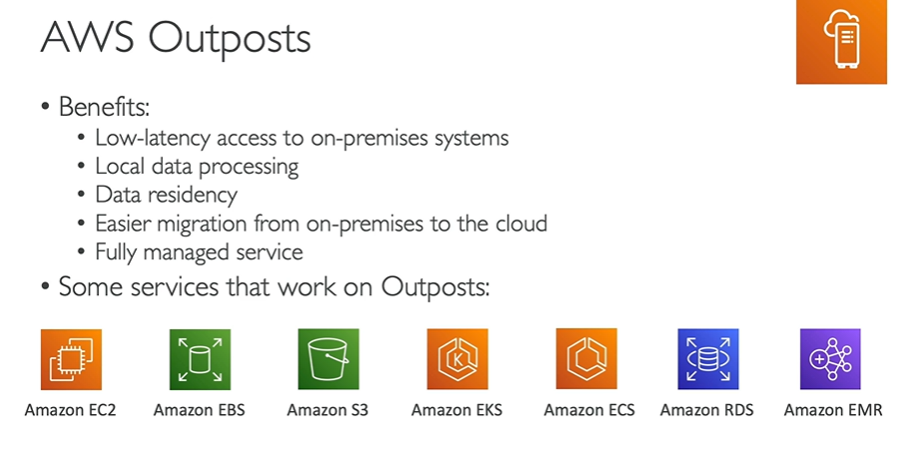

**AWS Wavelengths:** Wavelength Zones are infrastructure deployments embedded within the telecommunication providers, datacentres at the edge of the 5G network.

Think of AWS wavelengths if you see 5G in your question.

**AWS Local Zones:** Places AWS compute, storage, database, and other selected AWS services *closer to end users to run latency-sensitive applications.*

AWS Region – N. Virginia (us-east-1)

AWS Local Zones: Boston, Chicago, Dallas, Houston, Miami,…

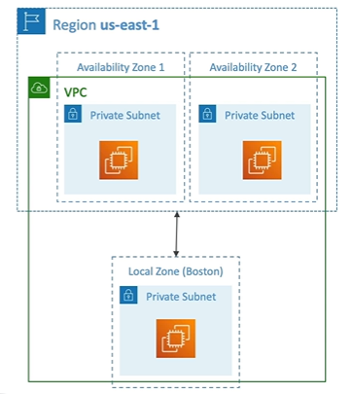

**Global Applications Architecture**

